Subject: Welcome

Dear [Mr.][Miss.][Mrs.] [Last Name],

Thank you for selecting Geojit BNP Paribas as your preferred broker on ManageMyFortune.com.

**We are pleased to inform that you have completed the registration formalities and can now start investing via** [**http://www.ManageMyFortune.com**](http://www.managemyfortune.com)**. Your Trading & Demat account has been registered with Geojit BNP Paribas Financial Services Limited.**

Your **TRADE CODE** and **TIN** are mentioned below.

**Account Information**

|  |  |  |  |  |  |  |
| --- | --- | --- | --- | --- | --- | --- |
| Trade Code | TIN (Telephone Identification Number) | Depository Participant | DP Client ID | DP ID | Registered Email ID | Registered Contact Nos |
| MMFXNNNA | 1234578 | Geojit BNP Paribas | 123455678 | IN12345 | sameer.naringrekar@gmail.com | Mobile:96999973750  Landline: 022-22421968 |

Branch Details:

|  |  |  |  |  |
| --- | --- | --- | --- | --- |
| Branch/Authorised person Name | Branch/Sub Broker Code | Branch/Sub Broker Phone Nos: | Branch/Sub Broker Email ID: | Branch/ Sub Broker Timings: |
| ManageMyFortune Brokers Pvt Ltd | MMF | 022-40220790 | [managemyfortune@geojit.com](mailto:managemyfortune@geojit.com) | 9 am to 6 pm |

**We request you to follow the procedure mentioned below to get your TRADE PASSWORD:**

1. Visit http://[www.managemyfortune.com](http://www.managemyfortune.com)/geojit/getpassword to get your temporary password.

Change to “Get Password”

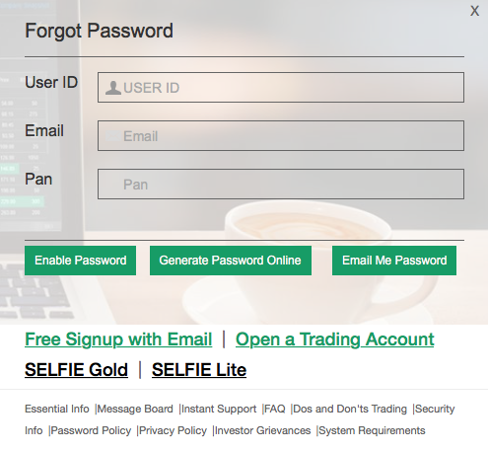

Change to “Trade Code”

1. Enter your TRADE Code, Email and PAN number. Click on Email Me Password. It may take up to 30 minutes for you to receive your temporary password via email from [get_password@geojit.com](mailto:get_password@geojit.com). Please check your Spam mail folder in case you haven’t received the password in 30 minutes.

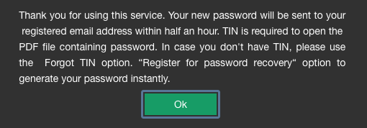

Change text to “Thank you for using this Service. Your new password will be sent to your registered email address within half an hour.”

1. Once you receive the email with the temporary password as an attachment, open the file with the TIN followed by first 4 alphabets in your PAN number (in CAPITAL LETTERS).
2. Visit http://[www.managemyfortune.com](http://www.managemyfortune.com)/geojit/resetpassword to set your new TRADE password.

[Include Image for resetting temporary password]

1. You have successfully generated your TRADE PASSWORD. Use the newly generated TRADE PASSWORD along with the TRADE CODE while confirming your trades on the platform.

[DO's and DONT's for trading](https://gcc.geojit.net/html/DosAndDonts.html)

You may please note that there is a risk of making loss while trading in stocks and derivatives and you should carefully consider your financial position before making any trades. Please note that we have not authorized any of our staff including dealers to trade on client’s behalf and request you to also refrain from such authorization or oral instructions. We advice you to take your investment decision on sound advice from reliable sources only as it may end in losses .We shall not be responsible for any claims for the same.

N.B: Customers are requested not to call on the Dealer’s Mobile phones for placing orders.

**Customer care details of ManageMyFortune.com (FIRST LEVEL SUPPORT)**

|  |  |
| --- | --- |
| Telephone | +91 (022) 4022 0790 |
| Timings | 9:00 a.m. to 6:00 p.m. – Monday to Friday |
| Email | [help@managemyfortune.com](mailto:help@managemyfortune.com) |
| Website | Help section on [www.ManageMyFortune.com](http://www.ManageMyFortune.com) |
|  |  |

**Customer care details of Geojit BNP Paribas**

|  |  |
| --- | --- |
| Toll Free No. | 1800-425-5501 / 1800-103-5501 - accessible from mobile & landline and supported by most service providers |
| Paid Line No. | 0484 3911777 (standard rates apply) |
| Timings | 8:30 a.m. to 5:30 p.m. – Monday to Friday and  10.00 a.m. to 1:00 p.m. – Saturday |
| Email | [customercare@geojit.com](mailto:customercare@geojit.com) |
| Website | [www.geojitbnpparibas.com](http://www.geojitbnpparibas.com/) - You may visit this website for latest news, stock market quotes, financials and relevant company information, IPO, mutual fund details and much more  Customer Care site: Your transaction information, copy of signed documents, demat holdings, ledger balances, general information, etc. can be viewed in our secure Customer Care website <https://gcc.geojit.net> |

We will be happy to receive your suggestions and feedback about your experience at customercare@geojit.com.

Regards,

Geojit BNP Paribas

**'Never disclose your password to anyone. Only you can safeguard your own security.'**